**Lab Task-3**

**Instructions: Please read carefully**

* Please rename this file as only your ID number **(e.g. 20-*****-3.doc or 20-*****-3.pdf).**
* Submit the file before **1:45PM PM on 01/11/2020** in VUES section labeled **Lab task 4. If you cannot complete the full task, do not worry. Just upload what you have completed.**

|  |
| --- |
| **Question No.1**  Write a program using loop to print numbers from 1-10 in forward and backward direction. You have to show this work using all the three loop syntax. |
| **Your code here:**  1.  // using for loop  #include <iostream>  using namespace std;  int main(){  cout<<"Forward: "<<endl;  for(int i=1; i<=10; i++){  cout<<i<<endl;  }  cout<<"Backword: "<<endl;  for(int j=10; j>=1; j--){  cout<<j<<endl; }  return 0;  }  2.  //using while loop  #include <iostream>  using namespace std;  int main()  {  int x = 1;  cout<<"Forward: "<<endl;  while(x <= 10)  {  cout<<x<<endl;  x++;  }  cout<<endl;  int y = 10;  cout<<"Backward: "<<endl;  while(y >= 1)  {  cout<<y<<endl;  y--;  }  }  3.  //using do while loop  #include <iostream>  using namespace std;  int main()  {  {  } int i = 1;  cout<<"Forward: "<<endl<<endl;  do {  cout<<i<<endl;  i++;  }  while (i <=10);  cout<<endl;  { int j=10;  cout<<"Backword: "<<endl<<endl;  do {  cout<<j<<endl;  j--;  }  while (j >=1);  }  } |
| **Your whole Screenshot here: (Console Output):** |

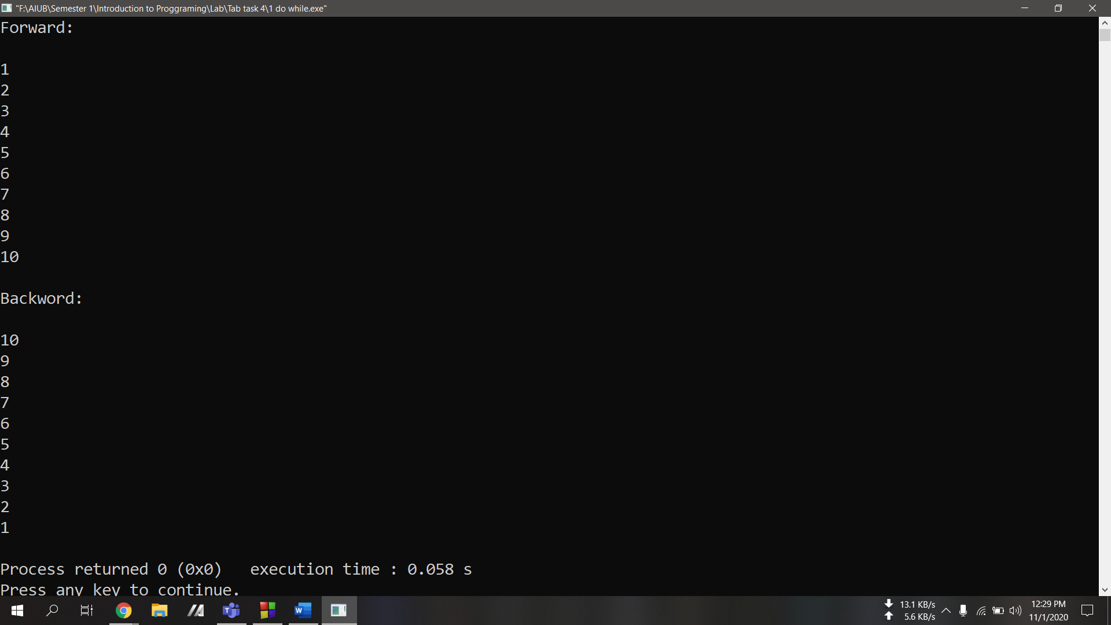

|  |
| --- |
| **Question No.2**  Write a program using while loop to find all the even and odd numbers between a range input by the user. |
| **Your code here:**  #include <iostream>  using namespace std;  int main()  {  int n,m, x;  cout<< "Input smaller range ";  cin>>n;  cout<< "Input bigger range ";  cin>>m;  int e=n;  cout<<"Even number: "<<endl;  while( e<= m)  {  if (e%2==0 )  {  cout<<e<<endl;  }  e++;  }  int r=n;  cout<<"Odd numbers: "<<endl;  while( r<= m)  {  if (r%2!=0 )  {  cout<<r<<endl;  }  r++;  }  } |
| **Your whole Screenshot here: (Console Output):** |

|  |
| --- |
| **Question No.3**  Write a program that will find the sum of all numbers between 0-10. Use both for and while loop. |
| **Your code here:**  1.  //using for loop  #include <iostream>  using namespace std;  int main()  {  int i,sum=0;  for (i = 1; i <= 10; i++)  {  sum=sum+i;  }  cout << "The sum of 0-10 is: "<<sum << endl;  }  2.  //using while loop  #include <iostream>  using namespace std;  int main()  {  int i=1 ,sum=0;  while (i <= 10)  {  sum=sum+i;  i++;  }  cout << "The sum of 0-10 is: "<<sum << endl;  } |
| **Your whole Screenshot here: (Console Output):** |

|  |
| --- |
| **Question No.4**  Write a program to find the sum of all even numbers between a range input by the user, You can use any loop syntax. |
| **Your code here:**  #include <iostream>  using namespace std;  int main()  {  int x,y,sum = 0;  cout << "Input smaller number of range : " ;  cin >> x;  cout << "Input bigger number of range : " ;  cin >> y;  cout << "Sum of Even Numbers : ";  for (x; x<=y; x++){  if(x%2 == 0){  if(x==y){  cout << x;  }else  cout << x << " + " ;  sum = sum + x;  }  }  cout << " = " << sum << endl;  } |
| **Your whole Screenshot here: (Console Output):** |

|  |
| --- |
| **Question No.5**  Using nested draw the following figure  *  **  ***  ****  *****  ******  *******  ********  *********  ********** |
| **Your code here:**  #include <iostream>  using namespace std;  int main()  {  for (int i=1; i<=10;i++)  {  for (int j=1;j<=i;j++)  {  cout<<"*";  }  cout<<endl;  }  } |
| **Your whole Screenshot here: (Console Output):** |

|  |
| --- |
| **Question No.6**  Using nested loop to draw the following figure  1  1 2  1 2 3  1 2 3 4  1 2 3 4 5  1 2 3 4 5 6  1 2 3 4 5 6 7  1 2 3 4 5 6 7 8  1 2 3 4 5 6 7 8 9 |
| **Your code here:**  #include <iostream>  using namespace std;  int main()  {  for (int i = 1; i <= 9; i++) {  for (int j = 1; j <= i; j++) {  cout << j << " ";  }  cout << endl;  }  } |
| **Your whole Screenshot here: (Console Output):** |